CHRONICLES OF LAST WEEK
September 11, 2019

Dear Family & Friends of Susana Homes,

SIBLING CARE IS EVERYTHING AT SUSANA HOMES!
The long vacation is finally coming to an end. We are all gearing up to get back to school. Becky has started braiding hair one after the other and in readiness for Monday, September 16. At Susana Homes, this is called SIBLING CARE. We do our work so that we can take care of one another. While Becky may be busy braiding hair, Nosa is busy walking Emmy-Bob and Barbra may be reading to the younger ones. At Church, Sondra can be holding Emmy-Bob and will take care of him until Church is over. Those who are too small to hold others play together and keep busy. Mama has always said that we take care of one another, no matter what. She says that is what it means to be family.
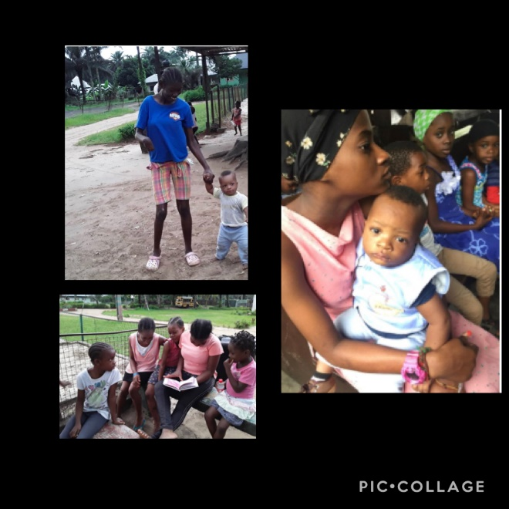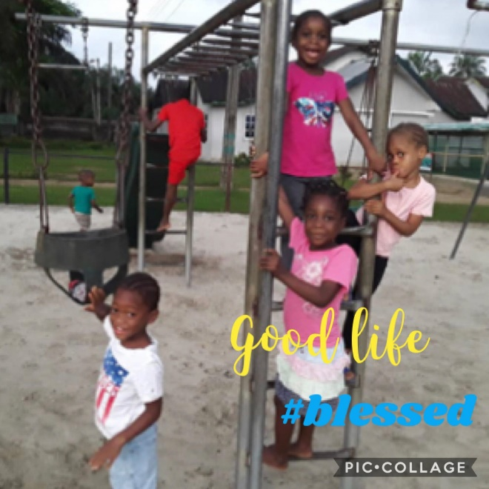

And of course Eunice and all the big children helped to get Isaac ready for school. Isaac is a toad in secondary school this year. This means he is a beginner in secondary school; having just graduated from primary school in July. He has finished elementary school and now he is going over to the Christian Comprehensive College (CCC) at Susana Homes. Because it is his first year, he has to leave before everybody else in order to attend the New Student Orientation. He will be in Junior Secondary 1. Isaac has done extra lessons on Reading and Basic College Mathematics during this long vacation. We hope that the extra lessons are going to help him do well in his new class. We miss him already!

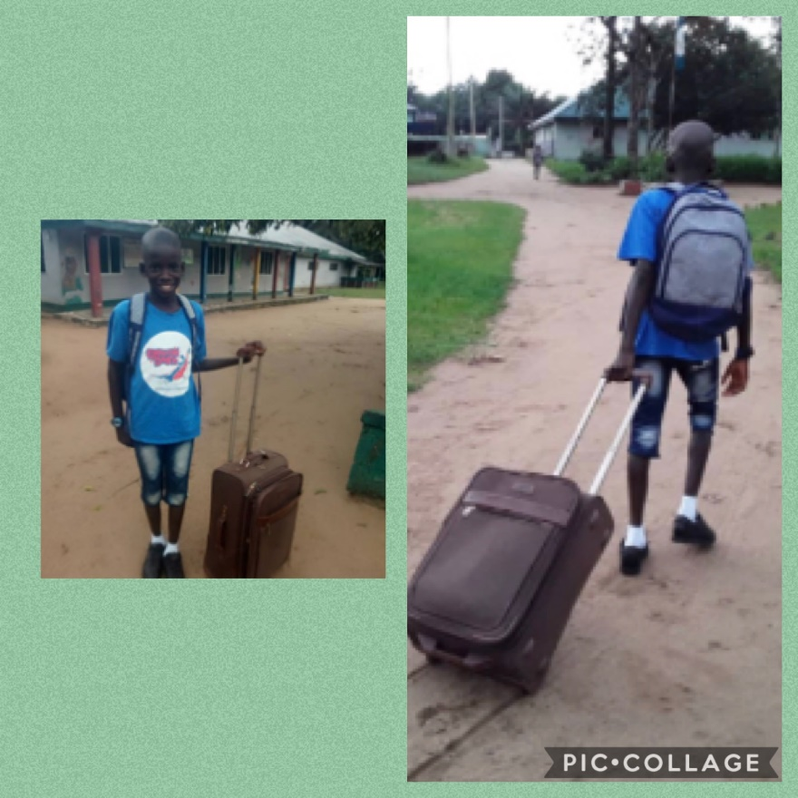

Talking about Sibling care, Evidence and I took Emmy Bob, George, and Baby James to the Primary Health Centre for immunizations on Wednesday. Baby George is now crawling! He has started earlier than we had expected. So many people love him and are always cheering him on as he tries to crawl.

Here is Auntie Chinaza again with news from school…
Compliments to you all our dearest friends and families! Once again we bring to you love and joy filled with warmth and pray that you have blissful days this week. We have started school resumption activities in earnest. All of us and the staff of the school are involved in activities of cleaning and renovations. Both boys and girls hostels have new fresh looks as we awaited the coming of new students on Monday, September 9.
Our own John, Wisdom, and Joy are being trained as auxiliary teachers. When school resumes fully on the 16th, they will fill in where we lack enough teachers. Joy is already in the university as an education major, so she is getting good training and practice for future use. It has been a long holiday and we can’t wait to have our students back to school on Monday. Our children are also eager to return to school to see their friends again. I will make sure I tell you everything next week.
So that is the news from Susana Homes for this week, and just so you can celebrate with us, here is a list of our Birthdays for the month of September:
Barbara -- September 20
Wisdom -- September 22
Emmy-Bob -- September 29
So until next week, it’s me Obi and Auntie Chinaza wishing you a joyous and prosperous week until we write again.

