CHRONICLES OF LAST WEEK
August 13, 2019

Warm greetings beloved family and friends of Susana Homes! It’s me, Obi, bringing you news of last week and as promised!

Sunday worship was truly joyful and Joy made it more special by serving a delicious Sunday meal of rice and stew with goat meat for everyone. Yes, we received our monthly goat from Auntie Bose and Uncle Sam – thank you!! Grappy said we could use it for the Sunday meal. It was so delicious!

All the children have been playing a lot, especially since they know that holiday school will start this week. Beginning today, the older children are going to start teaching the younger ones. We have planned different activities like lessons from 9:00 – 12:00 and then football, table tennis, etc. later in the day. The little ones play on the playground building sand castles and swinging happily! Play as we know is an integral part of childhood so, for this holiday, we are making sure the children get to play in addition to doing their portions.

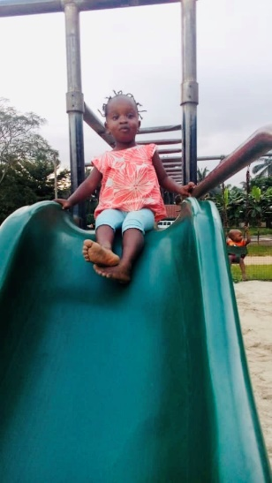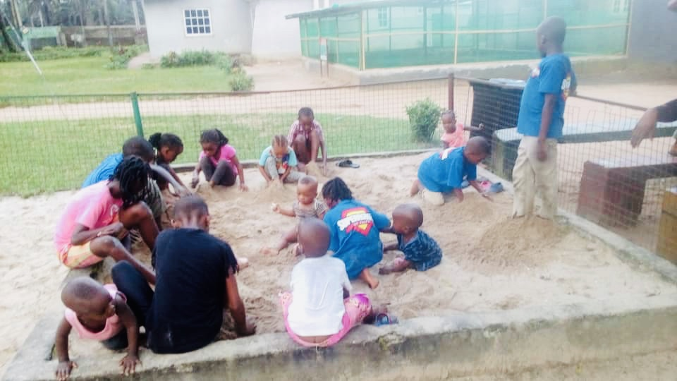

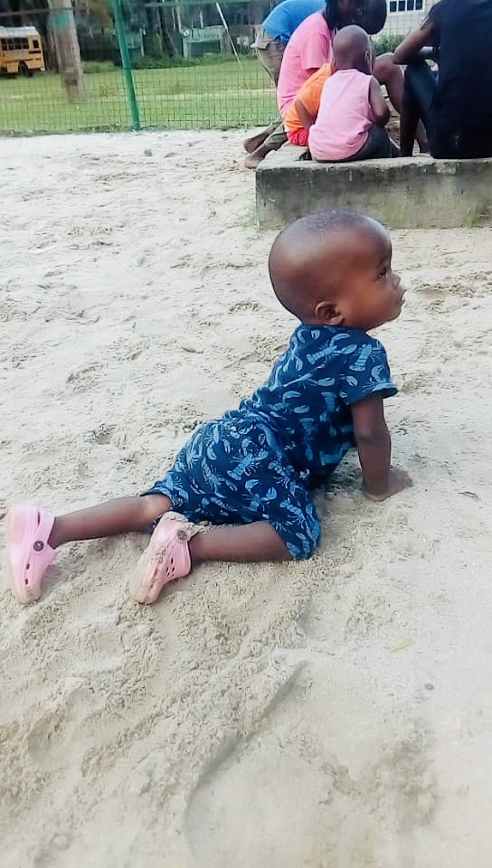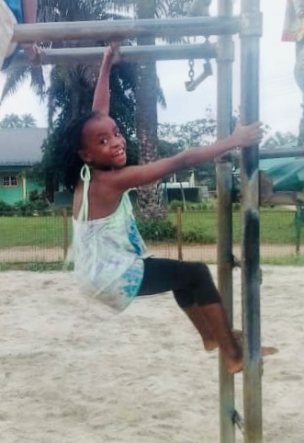

Eunice reports that Sondra, Roseline and Jay Jay fell sick during the week and were given medications. They are all sound in health now. Ken injured his leg and the nurse cleaned his wound. Nosa has a boil and is getting warm compresses twice per day.

Eunice also reports that one of the pigs gave birth to 7 piglets on Monday. The pigs eat a lot so we go to the village often to get cassava peelings to feed them so they will grow big and fat.
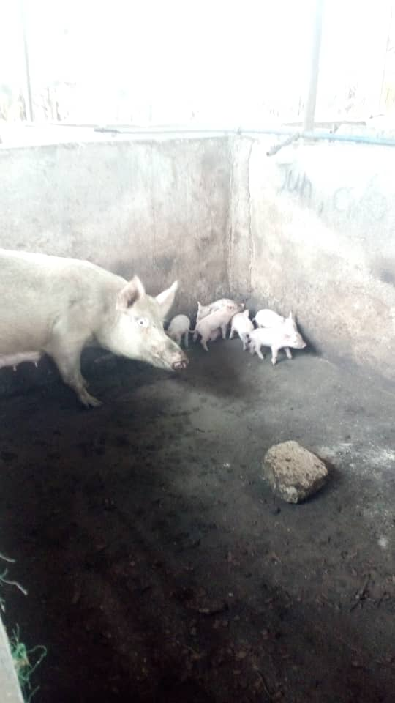
Guess who went home!!
On Sunday we gathered to say goodbye to Pam Pam (Pamela). Pamela became our little sister almost 4 years ago when her mother died giving birth to her. Her older sister came to live with us and take care of her for the past week so that Pamela could become acquainted with her and not go home to complete strangers. On Sunday her father and other people came and we had a big party to tell Pam Pam goodbye. Pamela was named for Auntie Pamela Proctor of Missouri and Mama Chi always thanks all of our family and friends for sharing their names with us. Thank you Auntie Pamela. We pray that her birth family will continue to love her and teach her to love God as Mama Chi and all of us have in the last 3 years and 11 months.

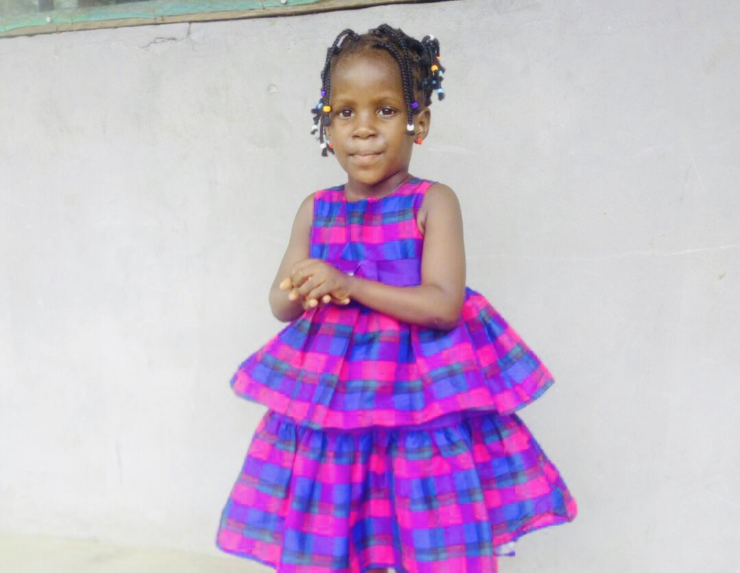

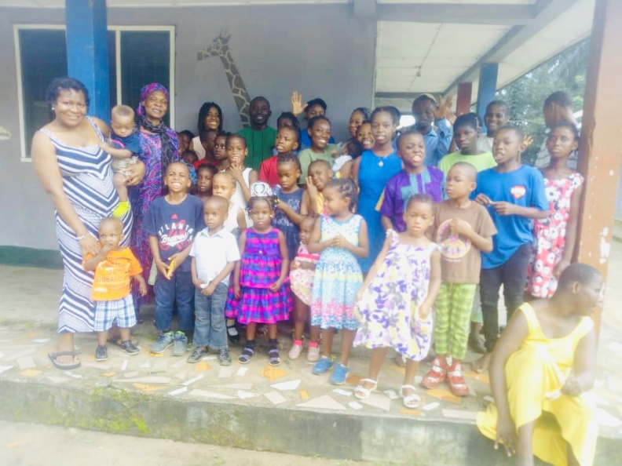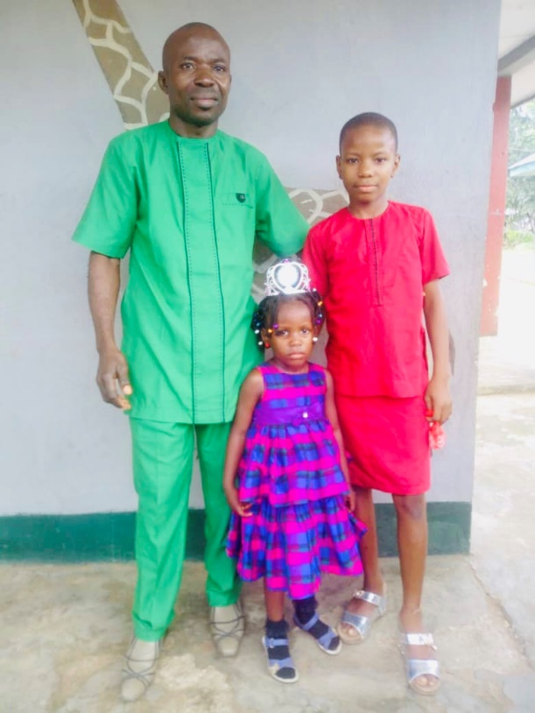

It rained cats and dogs this week but that didn’t stop any of us from carrying out our duties effectively. We tended the gardens and we are getting ready to process palm oil this week. We now have some really strange beans growing in our garden. Mama Chi planted them and now there are beans everywhere! Pa Steve and Ma Jane gave the beans to Mama Chi when she visited their house. They really look different from any beans we have in Nigeria but Mama Chi said we can eat them as soon as they are ready. Our unique beans will be ready to harvest soon and we will enjoy the first fruits!
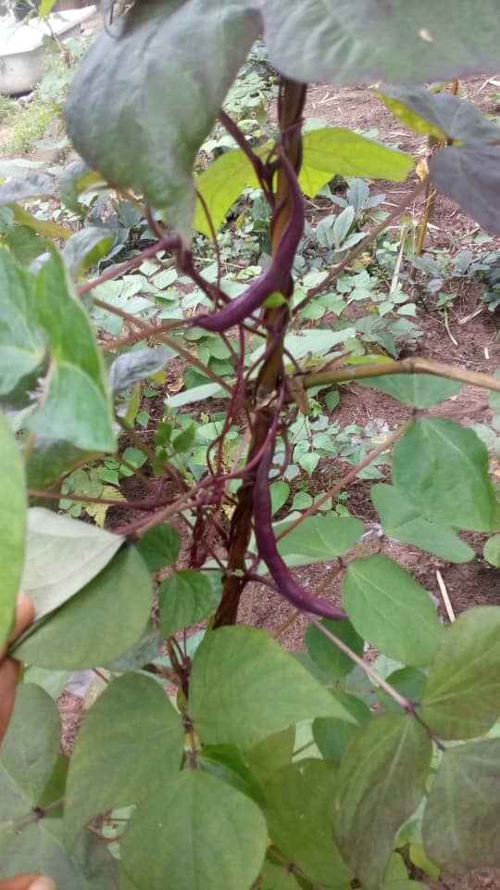

We have a lot more news to share with you and we will do so next week. Until then, it’s me Obi saying remain blessed in Jesus’ name!

